Amity University Tashkent in Association with Statistical Society in Tashkent
Presents
Workshop on Data Analysis for Students and Researchers Using STATA and R
PHASE II
Date: 29th April, 2023
Resource Persons:
- Dr. Akram Hasanov, Senior Lecturer, Monash University (Malaysia Campus)
- Dr. Rustam Ibragimov, Professor of Finance and Econometrics, Imperial College Business School, London UK.
- Dr. Anita Banerjee (HoD), Department of Management and Social Sciences, AUT
- Dr. Rajneesh Kler, Associate Professor, Department of Management and Social Sciences, AUT
- Dr. Indrajit Sinha Ray, Assistant Professor, Department of Management and Social Sciences, AUT
In continuation of the very successful 2-day workshop held in December 2022, Department of Management and Social Sciences, Amity University in Tashkent presents the Phase II of the workshop to be scheduled on April 29th 2023. The first workshop witnessed participation of 36 individuals (a healthy mix of students, researchers and faculty members) from various Universities and Institutions nation-wide. It covered the introductory topics such as CRLM models, OLS estimation, Multiple regression Model, Assumptions and Violation, LSDV Model and Static Panel Estimation Models. The feedback received from the participants was highly positive and further workshops were recommended.
The aim of these workshops is to create a common platform of statisticians and econometricians for encouraging research ideas and make young researchers/ faculty members aware of the usefulness of data analysis tools and techniques. Following Topics are intended to be delivered in Phase II.
- Simultaneous Equation Models: Identification and Methods Using IV technique and 2SLS Regression
- Distributed Lag Models: With one variable and Koyck Transformation (ARDL)
- Introduction to Time Series Modeling: The AR Process, the MA process and ARIMA process with post estimation tests.

Participation Fee (Proposed)*
Participant Category | National (Uzbekistan) | International
Industry | Som 100,000 | $ 10
Faculty | Som 75,000 | $ 8
Student / Research Scholars | Som 50,000 | $ 5

*Includes Certificate / E-certificate and lunch for offline participants
Participants (National) can pay by using the QR code above.
Registration Link: https://docs.google.com/forms/d/1U53c0wRXYZ2NsB_q3oD3DxC_buR9xuMMaSgEF4rtJP0/edit
After the Payment Please register using above link.

Resource Person
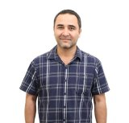
Dr. Akram Hasanov, Senior Lecturer, Monash University (Malaysia Campus) Member of “The Statistical Society in Tashkent”.
A PhD from University Putra Malaysia in 2012. Prior to joining Monash University Malaysia, he was a post doctorial research fellow at University Putra Malaysia. His principal research interests lie in the areas of time series analysis and forecasting, applied econometrics and financial volatility modelling. His research papers have been published in a number of international refereed journals. In addition, he was an invited speaker and presented papers at international conferences. Obtained several international and national competitive research grants. Also, refereed articles for international journals of high-esteem such as Energy Economics, Economic Modelling, and Journal of Applied Statistics. His more recent specific research investigates the volatility forecasting performance of a wide variety of conditionally heteroskedastic models in the context of biofuel feedstock markets in the presence of structural breaks. In this research, the model specifications allow for different conditional distribution functions in the rolling window estimations. At Monash University, he has taught Financial Econometrics, Applied Econometrics, Survey Methods and Managerial Statistics, and Operations Research. Currently, he is supervising and co-supervising several PhD and Honors students.
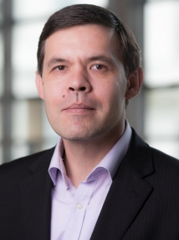
Dr. Rustam Ibragimov, Professor of Finance and Econometrics, Imperial College Business School, London UK, Member of “The Statistical Society in Tashkent”.
Rustam Ibragimov joined the Imperial College Business School as a Professor of Finance and Econometrics in 2012. Professor Ibragimov received his Ph.D. in Economics from Yale University in 2005. He also holds a Ph.D. degree in Mathematics from the Uzbek Academy of Sciences. Following his graduation from Yale and prior to joining the Imperial, Rustam Ibragimov was an Assistant Professor (2005-2009) and then an Associate Professor (2009-2012) at Harvard’s Economics Department. Over his academic career, he also held visiting positions at the Judge Business School at Cambridge, the Nuffield College at Oxford, the Department of Statistics at Columbia University, and other research and education centres.

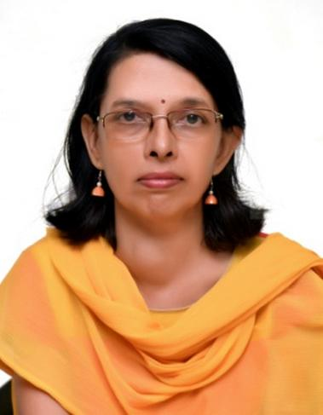
Dr. Anita Banerjee
(HoD, and Associate Professor, Department of Management and Social Science, Amity University Tashkent)

She is a PhD in Economics. She has 18 years of experience in Academics and research. Her areas of interests are Development Economics and Health Economics

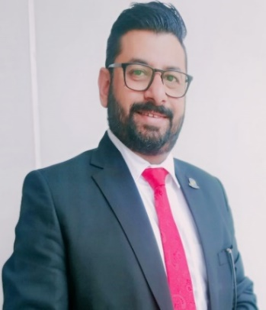
Dr. Rajneesh Kler
(Associate Professor, Department of Management and Social Science, Amity University Tashkent)
Dr. Kler is a PhD in Economics and have earned four Master’s degrees in Area of Economics (international Financial Economics, Applied econometrics), International Business and Economics of Education. He has 14 years of teaching Experience. His areas of specific interests are in applied econometrics and internationalization and globalization of higher education.
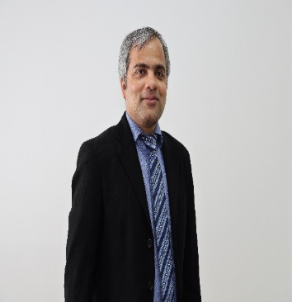
Dr. Indrajit Sinha Ray
(Assistant Professor, Department of Management and Social Science, Amity University Tashkent)

Dr. Sinha Ray completed his Ph.D. in Political Science in the USA. Before that, he received his Bachelor's and Master's degree in Economics from India. His research interests lie in the fields of Political Economy, Development Economics, Game Theory, and Public Policy.

Workshop on Data Analysis for Students and Researchers Using STATA and R
Schedule
29th April 2023

Time (Tashkent, GMT+5) | Topic | Resource Person
9:30 AM - 9:45 AM | Registration (offline Participants) | Students Team
9:45 AM - 10:00 AM | Inaugural, Professing Phase I and Welcoming the Participants | Dr. Indrajit Sinha Ray
10:00 AM - 11:00 AM | Simultaneous-Equation Models: Problem of Identification 2SLS Method of Estimation | Dr. Akram Hasanov
11:00 AM - 11:30 AM | Hands on with STATA / R for 2SLS | Dr. Rajneesh Kler
11:30 – AM – 12:30 PM | Dynamic Econometric Models: Autoregressive and Distributed Lag Models and the KOYCK approach for Estimation | Dr. Indrajit Sinha Ray
12:30 PM – 1:00 PM | Hands on with STATA / R for KOYCK Transformation | Dr. Indrajit Sinha Ray
1:00 PM – 1:30 PM | LUNCH BREAK | -
1:30 PM – 2:30 PM | Time Series Econometrics Basic Ideas: Stochastic Processes, Stationarity Test, Unit Root Test and Cointegration | Dr. Rustam Ibragimov
2:30 PM – 3:30 PM | Hands on with STATA / E-View / R on above | Dr. Indrajit Sinha Ray
3:30 PM – 5:00 PM | Time Series Forecasting (Univariate): AR Process, MA Process and ARIMA Process | Dr. Indrajit Sinha Ray
5:00 PM – 5:30 PM | Hands on with STATA / E-Views / R on above | Dr. Indrajit Sinha Ray
5:30 PM – 5:45 PM | Vote of Thanks | Dr. Rajneesh Kler
5:30 PM – 6:00 PM | Valedictory and Certificate Distribution | Dr. Anita Banerjee / Dr. Naina Chaudhary / Mr. Bobur Abdullayev

